# Creating frames of reference for chert exploitation during the Late Pleistocene in Southwesternmost Iberia.

# 1 Introduction

Southwestern Iberia has often been considered a key area to understanding techno-cultural transitions from the Middle Paleolithic to the end of the Upper Paleolithic. As a territory located at the tip of the European continent and with a generally stable climate even during the coldest periods punctuating the Late Pleistocene, it has been regarded as one of the most significant glacial refugia in Europe (Hewitt, 2000; Gómez and Lunt, 2007; González-Sampériz et al. 2010; Carvalho et al., 2022). For this reason, Southern Iberia has frequently been at the center of some of the most debated topics regarding Late Pleistocene human adaptations.

A particularly good example is the region’s role in being one of the last territories to be occupied by Neanderthal populations right before their complete disappearance (Finlayson et al., 2006; Zilhão et al., 2017). Neanderthals occupied the European continent for more than 300 000 years and are thought to have disappeared while modern humans arrived on the territory (Trinkaus and Howells, 1979; Mellars, 2004; Finlayson et al., 2006; Jennings et al., 2011; Rogers et al., 2017). The last territory where Neanderthal populations seemed to exist was Southern Iberia, around c. 37 thousand years ago (Zilhão et al., 2017), or perhaps even earlier (Finlayson et al., 2006; Tzedakis et al., 2007; Carvalho et al., 2022). This region is key to understanding how the Neanderthals survived until such a later chronology, the degree and types of interaction those populations may have had with modern humans (Finlayson et al., 2006; Zilhão et al., 2017), and how and why they eventually went extinct (Dalén et al., 2012; Melchionna, 2018).

Another example is Southwestern Iberia’s importance in the discussion of Upper Paleolithic transitions. Previous studies have discussed the territory’s potential as a refugium during cold and harsh climatic conditions (Gómez and Lunt, 2007; Rodríguez-Sánchez et al., 2010; Jennings et al., 2011). The Heinrich Event 2 (HE 2) at the onset of the Last Glacial Maximum (LGM), is a period marked by important social and technological transformations. This climatic event was characterized by abrupt and drastic climatic changes that impacted human behavior all across westernmost Europe (Gamble et al., 2004; Sanchez-Goñi and Harrison, 2010). The identification of a Proto-Solutrean phase in central and southern Portugal with a very distinct index fossil (the Vale Comprido point), and its direct association with the HE 2, put these regions amongst some of the most important case studies of how environmental dynamics have affected human adaptations during the last glacial. Other studies have expanded upon this notion of climatic refugia during harsh climatic events, to understand the Iberian Peninsula as a long-term eco-cultural refugia (Cascalheira et al., 2017b). Using this framework, this territory would consist of several ecological niches, consistently used through time, possibly due to the stability in the richness and variety of resources. This continuous use would then create long-term regional adaptative structures, which when correlated with the ecological niches, Cascalheira et al. (2017) have referred to as eco-cultural niches. In fact, it seems that a large number of caves and rockshelters in Iberia are multi-layered, giving validity to the aforementioned framework (Schmidt et al., 2012), but also providing an exceptional opportunity to apply these theories and frameworks to understand adaptative and resilient patterns of Human behavior throughout the Upper Paleolithic. One such example is the site of Vale Boi, where cross-scale complex interactions have been identified, displaying resilient behaviors throughout the Upper Paleolithic maintained by their eco-cultural niche, but also adaptation behaviors motivated by niche diversity, social networks and climatic changes (Cascalheira et al., 2017b).

In fact, Vale Boi, a shelter and open-air archaeological site located in southwesternmost Iberia (Algarve, Portugal), comprises one of the most complete Upper Paleolithic chronocultural sequences of Iberia (Bicho et al., 2012). As such, the site offers the opportunity to investigate critical topics and apply new frameworks and theories with impact on Late Pleistocene research on Human behavior. A great amount of studies have originated from the archaeological site of Vale Boi, and have aided in understanding the aforementioned topics, as well as the several technocomplexes and the transitions between them (i.e., Bicho et al., 2012, 2017; Manne et al., 2012; Pereira et al., 2016). A large portion of these studies has focused on lithic technology (i.e., Cascalheira, 2010; Marreiros et al., 2015; Belmiro et al., 2020). Unlike what happens in other areas of Portugal (i.e., Aubry et al., 2012, 2022; Pereira et al., 2016a), archaeological studies focusing on raw materials, and especially chert, have been more scarce.

Several lithic technology studies from Vale Boi have approached raw materials, although solely through a macroscopic methodology, often related to the location of the settlement (i.e., [@bicho_o_2003]; Pereira et al 2016) or the description of the collection (i.e., [@cascalheira_tecnologia_2010], [@marreiros_lithic_2015]). The work of Veríssimo (2005), albeit focusing on the occurrence of chert in western Algarve which provided the initial basis for comparative studies with the assemblages from Vale Boi, also maintained a macroscopic component. Finally, the creation of LusoLit, a lithotheque currently hosted at the University of Algarve (Telmo et al. 2016), and the collection of samples from several outcrops in the region provided a new leap in the study of chert in the region. However, the samples from the Algarve are still in need of exhaustive analysis and interpretation. A few geological studies have also contributed to understand the availability and characteristics of chert in southern Portugal (i.e., Rocha, 1976; Ribeiro, 2005). Nevertheless, these studies are often unpublished or comprehend answers to geological questions, which hamper the comparative use of the data with archaeological assemblages. Furthermore, a large portion of chert-bearing outcrops in southern Portugal remains unstudied, both by archaeologists and geologists.

Given the presence of several chert-bearing outcrops in Southern Portugal, most of which remain unstudied, and the opportunity to conduct raw material studies in key sites from the UP such as Vale Boi, which demand complete knowledge of the geology of the territory, the Algarve stands as a region full of potential for an exhaustive, geoarchaeological study of chert. This includes the development of a complete lithotheque which may serve for comparative studies within the Algarve and outside, where chert may have been transported and traded.

As such, this paper aims to locate and characterize the nature of chert sources in the southernmost region of Portugal (Algarve) and their availability. Furthermore, it aims to test the potential of macroscopic and petrographic approaches to characterize the regional cherts and develop a methodological approach adapted to this study area.

## 2. Geological setting and chert outcrops

### 2.1. Geological setting

The Algarve is the southernmost region of Portugal, framed north by the Alentejo region and east by Spain. To the west and south, it is bordered by the Atlantic ocean. It extends for ~130 km E-W and ~50 km N-S and is characterized by a variety of geomorphic sub-regions and geological units, that make this region a complex territory (Fig. **). On the north sector of the Algarve, the Serra Algarvia is characterized by a mountainous range with a dense hydrographic network, which separates the Algarve from Alentejo. On the south sector, the Litoral is characterized by a flatter, long strip of land, that extends through all of the coastal strip of the Algarve. The Barrocal is nested between the other sub-regions and has a more moderate relief, characterized by carbonated Jurassic formations and important sub-terranean water circulation (Gago, 2007).

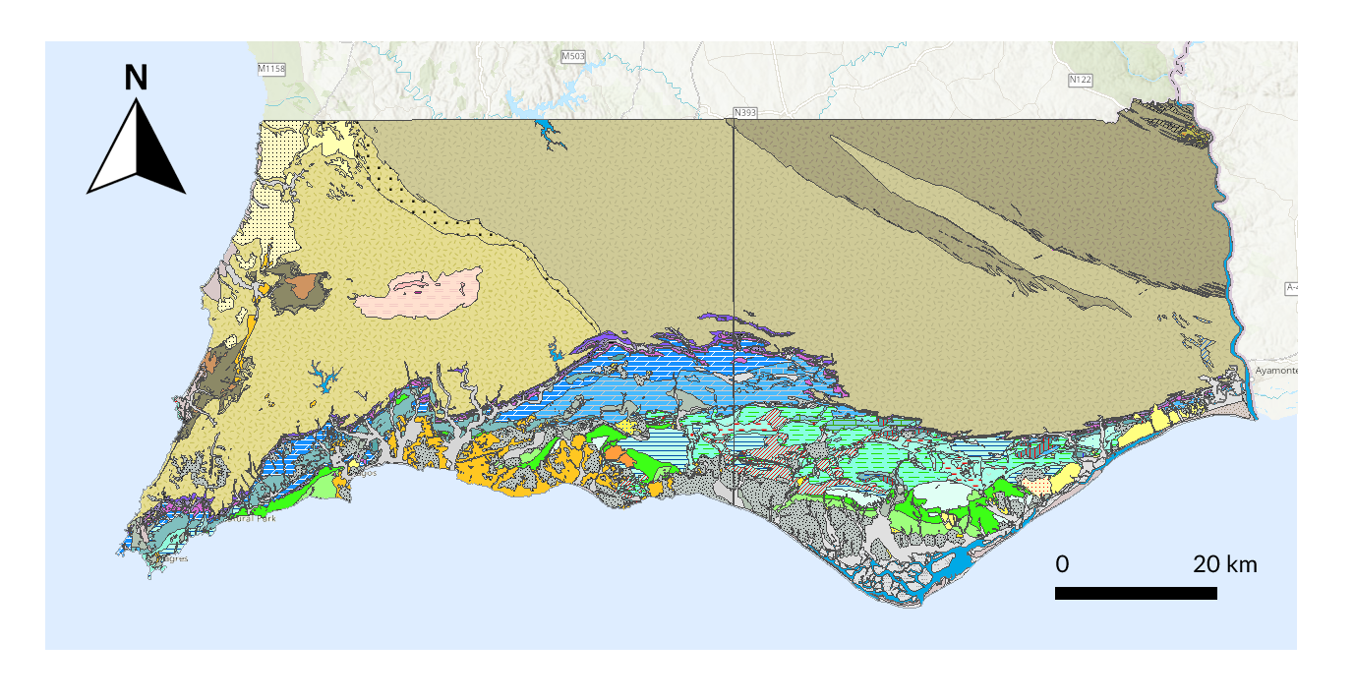

Fig. **: Geological map of the Algarve region, bordered north by the Alentejo region and east by Spain. The map represents the several geological layers and formations, as well geomorphic sub-regions. Adapted from the ArcGIS online geologic maps by LNEG (Laboratório Nacional de Energia e Geologia) and Instituto Geográfico Nacional.

Geologically, the Algarve is composed of two main geological units: the South Portuguese Zone (SPZ) and the Algarve basin. The SPZ is located in the north sector of the Algarve, extending up to Alentejo (Fernandes, 2012). Its main lithologies are schist, greywacke and quartzite (Fernandes, 2012; Pereira, 2016). The SPZ is overlain unconformably by the Mesozoic sedimentary rocks of the Algarve basin [@fernandes_new_2012]. The basin corresponds to the Mesozoic-Cenozoic sediments that outcrop south of the Algarve, from the westernmost to the easternmost point of the region, and it is associated with the opening of the central Atlantic Ocean and with the eventual oceanic crust formation in the western part of the Tethys sea, between the Algarve and North Africa (Terrinha et al., 2013). Paleozoic sedimentation of the basin started in the Triassic and continued thereon. In the Lower Jurassic (Lower Pliensbachian, also regionally known as Carixian) the basin was divided into two sub-basins – western and oriental sub-basins (Rocha, 1976; Terrinha et al., 2013). The existence of the two sub-basins and the expansion and retraction of the sea created a variety of sedimentation environments, such as external and internal platforms, continental, hemipelagic and deep marine (Terrinha et al., 2013), as well as moments of sedimentation hiatus. This variability in deposition environments created a variety of Paleozoic sedimentary facies, with moments of more or less homogeneity throughout this period. For example, during the Lower Pliensbachian, in the Lower Jurassic, the sediments in the western sub-basin can be described as marine of external platform, while the sediments of the eastern sub-basin can be described as marine of internal platform. During the Upper Jurassic however, the basin is marked by a moment of prominent lithofacies variation, followed by a moment of uniformity in both sub-basins (Terrinha et al., 2013).

Understanding the Algarve basin is key for raw material studies in the Algarve, especially when studying chert, since it is in the basin, more specifically in the Paleozoic sediments, where chert primarily outcrops in the region.

### 2.2. Chert outcrops

The presence of chert is commonly associated with carbonates in limestone and dolomite formations. This is explained by characteristics (such as the presence of water or specific temperatures and pH) that are ideal for both the formation of limestone and the precipitation of silica (Luedtke, 1992). The pelagic and marine environments of the Algarve basin during the Paleozoic gathered those such ideal characteristics, allowing the sedimentation and precipitation of limestone and silica, creating limestone layers with chert nodules. The existence of two basins with different sedimentation environments also shows potential for the precipitation of different types of chert throughout the basin and their differentiation. For example, during sedimentation, skeletal grains of fossils may be preserved. Many of these fossils are restricted to specific sedimentation environments and time intervals (Flugel, 2010), which may allow the identification of chert outcrops through the fossil content. The basin and sub-basins thus show potential for the existence of different geological formations with different chert types and their study.

Previous works, both geological and archaeological, confirm that chert is present in the Algarve in the Jurassic limestone or dolomitic limestone layers of the Algarve basin. This means that chert outcrops can be identified in the central/south sector of the region, from west to east. Variability in chert availability, as well as chert types, is expected, considering that during the sedimentation process, the Algarve basin was already sub-divided and in constant environmental change. Due to this, several formations with chert nodules can be identified in the Algarve, corresponding to different sub-periods of the Jurassic.

In the western sector of the Algarve, chert can be found in the Lower Jurassic limestone or dolomitic limestone layers (from the regional Carixian), often visible in areas where the layers are exposed, such as beach-generated cliffs and associated deposits. This includes outcrops such as Cabo de S. Vicente (CSV) and Praia do Belixe (PBLX). These sediments and chert nodules are also available inland, albeit more scarcely, as is the case of the small outcrop named Ferrel, 3 km from the current coastline. Lower Jurassic chert-bearing outcrops are barely existent in the center/east sector of the Algarve, with one single formation with micro-nodules identified in geological works [@oliveira_carta_1992].

Middle Jurassic geological layers with chert nodules are only found in the center/east sector of the Algarve in a geological formation called the Malhão Formation. The formation can be described as carbonated, from a marine sedimentation environment. Chert in this formation has been identified in two distinct layers: conglomerates with micritic limestone intercalations with chert beds and nodules, characterized by the presence of sponge spicules and radiolarians (Manuppela et al., 1987); microcrystalline limestones with chert nodules characterized by the presence of silicified malacofauna and silicified corals (Manuppella et al., 2007).

Finally, Upper Jurassic sediments with chert nodules have also been mostly identified in the center/east sector of the Algarve, attributed to the Jordana Formation. This formation is characterized by dark-gray limestones, with frequent secondary silicifications with abundant fossil fragments (Manuppela et al., 1987; Rocha et al., 1989; Manuppella et al., 2007). One single outcrop from the Upper Jurassic has been identified in the western sector of the Algarve basin, located at Praia da Mareta.

# 3 Materials and methods

To locate and characterize chert outcrops in southern Portugal and understand chert’s characteristics, a macroscopic and petrographic approach was applied to the study of geological samples which were collected through fieldwork.

A combination of methods in a multilayered approach is an important tool to reconstruct the geological and geographical origin of raw materials, especially since different methods have their inherent limitations. By combining these two different methodologies the goal was to create several layers of analysis, to which new layers may be added if necessary (Brandl, 2016). Several other similar methodologies and approaches have been applied in other regions (i.e., García-Simón and Domingo, 2016; Terradas et al., 2017; Tomasso et al., 2019; de Soler et al., 2020). However, the chosen analysis techniques should be adapted to the specific geographic context, the research questions, the problematics, and the characteristics of the types of cherts in question (Luedtke, 1992). Since only preliminary studies of raw materials were applied in the western portion of southern Portugal, and petrographic data has been shown to provide good results for the characterization of cherts in this region (Ribeiro, 2005), the two methodologies were chosen for the study.

The geological samples used in this study were obtained during fieldwork, between August 2021 and June 2022. The locations prospected were chosen after reviewing previously known research, which included preliminary raw materials studies in the region (Veríssimo, 2004; Pereira et al., 2016b), geological scientific papers, and theses focusing on the Algarve basin and concerning chert outcrops (Rocha, 1976, 1976; Marques, 1983; Ramalho, 1985; Ribeiro, 2005), and geological maps, which signaled the presence of chert nodules within the outcrops (Rocha et al., 1979, 1983, 1989; Oliveira, 1984, 1992; Manuppela et al., 1987; Manuppella et al., 2007). Unpublished data and coordinates for unprospected locations with potential for chert-bearing outcrops gathered during the organization of the LusoLit lithotheque were also prospected. Whenever coordinates or specific locations for known outcrops were available, these were directly visited and the surrounding area was prospected to understand the extension of the outcrops and possible secondary deposition outcrops nearby. Whenever no specific locations were described (for example, in geological maps) several locations with the potential to find chert outcrops within one larger formation were visited and prospected.

Samples were collected whenever possible, focusing on both primary and secondary outcrops. When chert nodules within one single outcrop showed macroscopic differences (such as differences in the color, texture, translucency, or cortex), samples of each different nodule were collected, to cover all chert variability within the outcrop. This variability was also recorded using a database (to distinguish between homogeneous or heterogeneous chert nodules within the outcrop) and through photography (Fig. **). All samples were registered with resource to a free android app (Archaeosurvey) which was designed for archaeological surveys, and records site location and characteristics (Cascalheira et al., 2017a), and has also been adapted for raw material source surveys (Abrunhosa et al., 2017). The version of the software used for fieldwork is an adaption of the latter apps and records data related to outcrop characteristics and conditions (i.e. abundance, visibility, access, geomorphology, chert morphology, and conditions). All data related to the app and dataset for the variables recorded can be found in the Supplementary Online Materials (SOM). Individual IDs were associated with each sample, which includes sequential numbers (based on recovery order, i.e., SP10) and outcrop code (i.e., PdA).

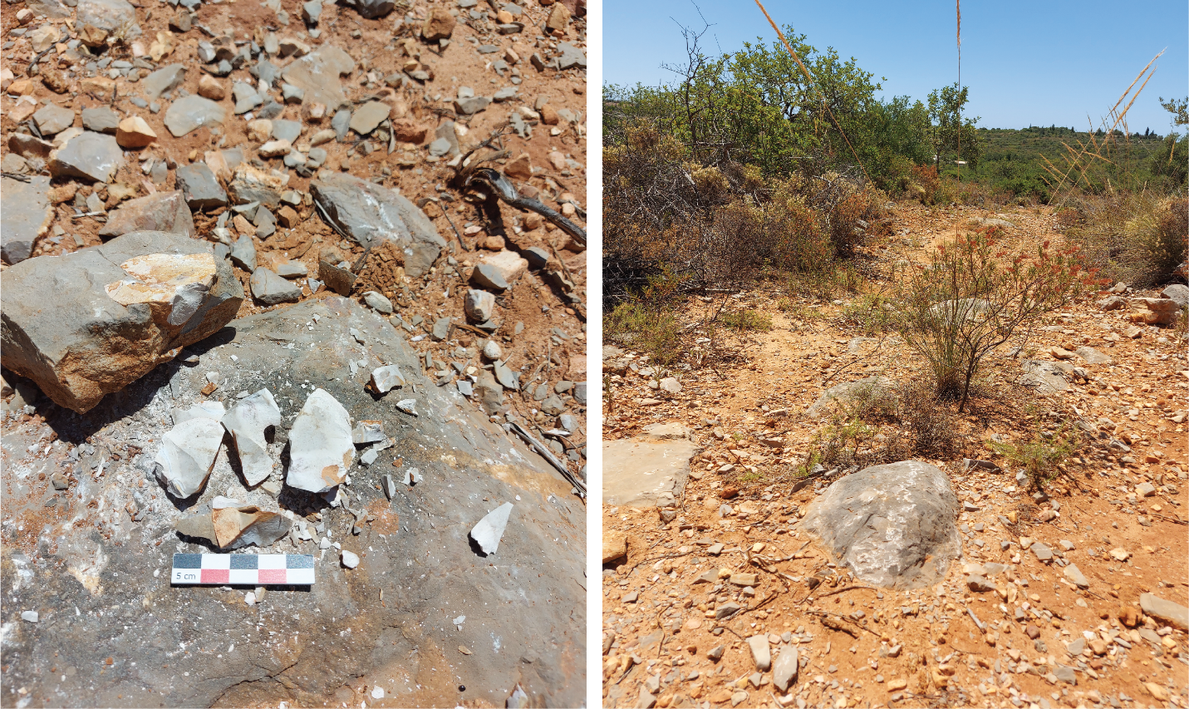

Fig. **: Sample SP65_MALH from the Malhão outcrop, collected during fieldwork. Left – chert samples collected and nodule still embedded in the parent rock. All chert macroscopic variability was recoded through photography upon sample collection. Right – general photo of the outcrop. The outcrops and points of reference were recorded for contextualization and easiness of future access.

A two-step approach was applied to characterize the geological samples. As a first step, the samples were analyzed macroscopically following a pre-established dataset. The variables were defined based on specialized literature (i.e., Luedtke, 1992; Crandell, 2005; Bressy, 2002), and the dataset with the variables can be found in the SOM. A small hand lens of 10x magnification was used for this analysis, followed by a higher magnification analysis with resource to a Nikon SMZ25 stereomicroscope, focusing primarily on inclusions and fossil content. Despite several caveats, especially related to the subjectivity and lack of quantitative variables (Bustillo et al., 2009), a macroscopic approach is currently still frequently used in chert raw material studies. For a comparative analysis of archaeological artifacts, other methods may be inconvenient or impossible to use, since they may be destructive and often difficult to apply to large assemblages. Macroscopic analyses have the advantage of being less costly and easy to apply. Establishing a reliable macroscopic characterization and understanding the potential of macroscopy to differentiate between cherts, outcrops and formations is essential for comparative studies between geological samples and archaeological assemblages and obtaining preliminary results. By then combining the macroscopic analysis with a petrographic analysis, other studies have shown that the subjective component of this approach can be minimized (Bustillo et al 2009).

The second phase of the study focused on the petrographic analysis of the geological samples. Thin sections were produced from geological samples of all formations, focusing on obtaining petrographic data that reflected the macroscopic variability. In total, 30 thin sections were produced (Table **), divided into three groups: 1) 20 thin sections of geological samples from different outcrops within the western section of the Algarve; 2) 9 thin sections of geological samples from different outcrops from the eastern section of the Algarve; 3) 1 thin-section of a geological sample recovered from previous works, which was not identified during our survey. Although primary outcrops were prioritized, thin sections of secondary deposition samples were also produced, to characterize the chert from most of the identified outcrops. To compare with the thin sections from this study, other thin sections from previous studies of Jurassic outcrops from the western Algarve (Ribeiro, 2005) were also consulted. All thin sections were analyzed using a Nikon LV100ND or a Leica DM2500 P and following standard petrographic description (full descriptions of the variables considered for the petrographic description can be found in the SOM).

Table **: List of thin section produced for the study and related information. UB refers to the University of Barcelona. TSL refers to the Thin Section Lab. Sample RT82 was collected prior to 2021, in previous raw material study works in the Algarve region, from the University of Algarve.

| Sample ID | Type | Laboratory | Outcrop | Sample collection |
| --- | --- | --- | --- | --- |
| SP6 | Covered | UB | Cabo S. Vicente | 2021 |
| SP7 | Covered | UB | Cabo S. Vicente | 2021 |
| SP9 | Covered | UB | Ponta dos Altos | 2021 |
| SP10 | Covered | UB | Ponta dos Altos | 2021 |
| SP14 | Covered | UB | Praia Belixe | 2021 |
| SP15 | Covered | UB | Praia Belixe | 2021 |
| SP18 | Covered | UB | Praia Belixe | 2021 |
| SP21 | Covered | UB | Belixe Sul | 2021 |
| SP23 | Covered | UB | Belixe Norte | 2021 |
| SP24 | Covered | UB | Cabo S. Vicente | 2021 |
| SP27 | Covered | UB | Cabo S. Vicente | 2021 |
| SP28 | Covered | UB | Aspa | 2021 |
| SP32 | Covered | UB | Foz dos Fornos | 2021 |
| SP33 | Covered | UB | Foz dos Fornos | 2021 |
| SP34 | Covered | UB | Ponta dos Altos | 2021 |
| SP34 | Covered | UB | Ponta dos Altos | 2021 |
| SP36 | Covered | UB | Ponta da Atalaia | 2021 |
| SP39 | Covered | UB | Andorinha | 2021 |
| SP40 | Covered | UB | Ferrel | 2021 |
| SP42 | Covered | UB | Boca do Rio | 2021 |
| SP59 | Covered | TSL | Jordana | 2022 |
| SP61 | Covered | TSL | Peral | 2022 |
| SP56 | Covered | TSL | Jordana | 2022 |
| SP54 | Covered | TSL | Guilhim | 2022 |
| SP53 | Covered | TSL | Guilhim | 2022 |
| SP58 | Covered | TSL | Jordana | 2022 |
| SP55 | Covered | TSL | Caliços | 2022 |
| SP50 | Covered | TSL | Casal da Colina | 2022 |
| SP52 | Covered | TSL | Casal da Colina | 2022 |
| RT82 | Covered | TSL | Praia Belixe | <2021 |

All descriptions (macroscopic and petrographic) and accompanying photographs are also available online on a database dedicated to the LusoLit litoteque.

The complete R code used for all the analysis and visualizations contained in this paper is available at our online research compendium: https://osf.io/fp7ta/. To produce those files, we followed the procedures described by Marwick et al. (2017) for the creation of research compendiums to enhance the reproducibility of research. The files provided contain all the raw data used in our analysis as well as a custom R project (Wickham, 2015) holding the code to produce all tables and figures. To enable maximum reuse, code is released under the MIT license, data as CC‐0, and figures as CC‐BY (for more information, see Marwick, 2016).

# 4 Results

Eighteen outcrops (primary and secondary) were revisited or newly identified in the Algarve region. Nine are located in the westernmost territory and nine to the east (Fig. **). From these, 69 samples were recovered and analyzed, of which 24 are isolated finds or in secondary settings.

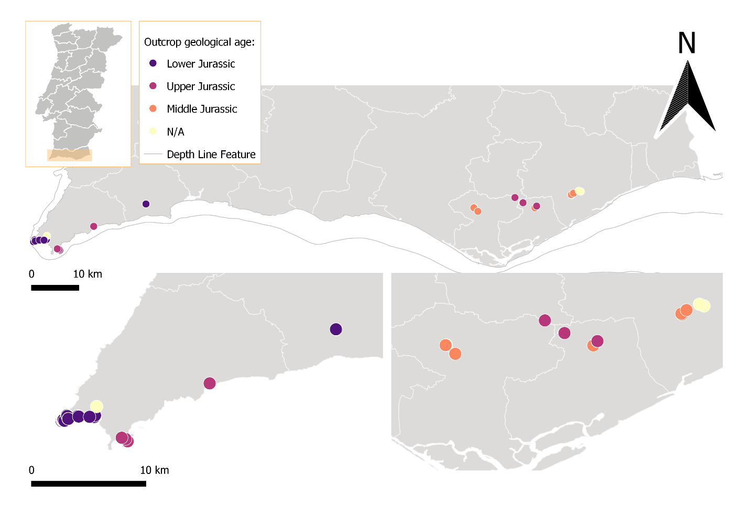

Fig. **: Map of southern Portugal (Algarve), with geological samples recovered during this study’s fieldwork. Colors represent the different geological ages, based on the formations where the cherts were found. N/A values represent samples (secondary sources or isolated finds) to which a geological age or formation could not be attributed.

On the westernmost part of the Algarve, there are mainly cherts from two different formations: Lower Jurassic and Upper Jurassic. The latter can be found in primary deposition in a single known outcrop - Praia da Mareta – or nearby in secondary deposition settings (Fig. **). Lower Jurassic outcrops are more common and, for that reason, have been better studied (**ribeiro_evolucao_2005**). These outcrops are heterogeneous, showing different geological characteristics and chert colors.

The Lower Jurassic cherts can be grouped into three main macroscopic types based on color (individual Munsell Color Chart codes can be found in the macroscopic description analysis table) and presence of fossil content: multicolored, yellow, red or purple type (MC); single grey/brown type (SGB); multicolored, yellow, red or purple with fossils type (MCF). The first two types are present in all outcrops. They are mainly characterized by dull to medium luster and opaque translucency, although some samples were sub-translucent. The feel ranges between smooth and semi-smooth, although many of the Belixe cherts are distinctly rough to the touch. In the MC cherts, fossil content is present but visible only as white, red, or yellow speckling. The SGB cherts show little fossil content, barely visible with the stereomicroscope. The MCF show a large quantity of larger fossils (~1000 µm), which are easily seen by the naked eye and can be identified under the microscope.

Petrographically the Lower Jurassic cherts of the Western Algarve are composed mainly of microcrystalline quartz, with textures that range mostly from wackestone to packstone. In more than 50% of the samples, no fossils can be identified, as all fossils, albeit common to very frequent, are poorly preserved, filled with chalcedony or quartz, and without any identifiable morphology. Whenever identifiable, fossils present in the sample are Echinoderms, Radiolarians, Sponge spicules, and a Bivalve shell (Fig. **).

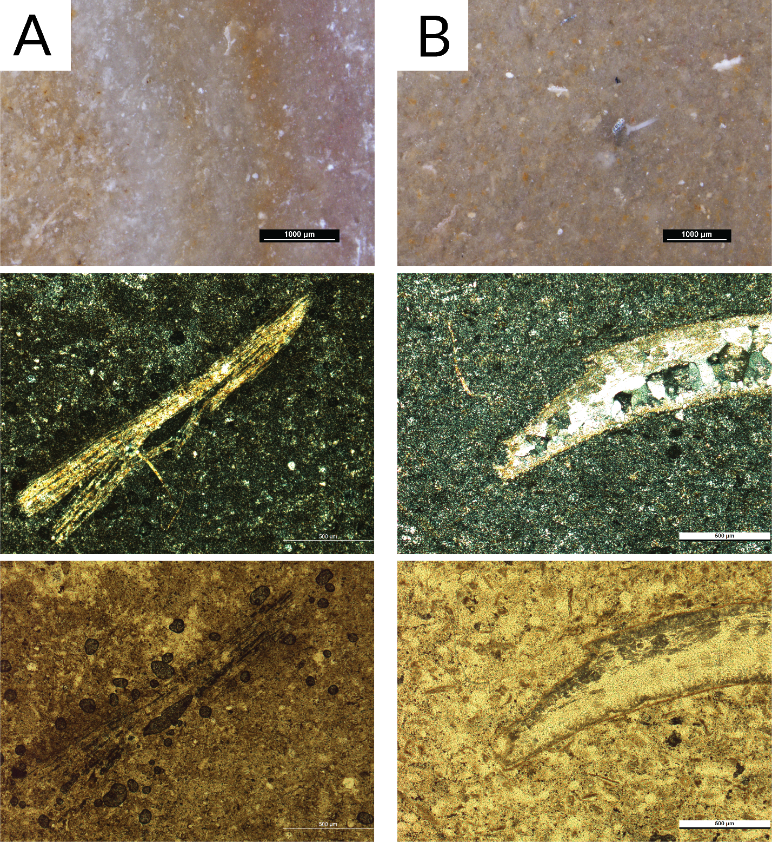

Fig. **: Column A – Sample SP7_CSV. Above: Macroscopic view with a stereomicroscope; Center and below: Microscopic view of a thin section (XPL and PPL respectively). An Echinoid spine, replaced by quartz but preserving the fossil’s original structure is present in the center of the images. Column B – Sample SP34_PdA. Above: Macroscopic view with a stereomicroscope; Center and below: Microscopic view of a thin section (XPL and PPL respectively). Includes the detail of a Bivalve shell replaced by at least two generations of quartz: microcrystalline quartz at the edges and macrocrystalline quartz inside of the shell.

Despite the similar characteristics between these cherts, the outcrops are heterogeneous and show varying characteristics between them, which may be of importance to distinguish between chert sources within the Lower Jurassic formation. These outcrops have been divided into four groups, following the available literature: Cabo de S. Vicente (including Cabo de S. Vicente and Aspa); Foz dos Fornos; Ponta dos Altos; Praia do Belixe (which includes Belixe Sul); and Ferrel.

The Cabo de S. Vicente (CSV) and Aspa (ASP) chert is characterized by abundant nodules in the natural rock banks of the cliffs, appearing as horizontal layers within the parent rock. The banks seem to be mainly dolomite or dolomitic limestones. The process of dolomitization seems to have affected the chert nodules, as they often present different levels of silicification from the peripheral areas of the nodule to the interior, which also affects the size and feel of the grain. In this case, the peripheral areas of the chert nodules are more dolomitized, with visible grain and distinctively rough to the touch, while the interior areas are more silicified and conversely finer and smoother. The nodules vary in size, ranging from small 4 cm in diameter circular nodules to bed-like groups of nodules with ~20 cm in width. At the Aspa outcrops, the nodules are less frequent and smaller. Due to the proximity to the cliffs, the visibility of the chert nodules is good, and in present times, small chunks of chert (without cortex or with small amounts of parent rock attached) accumulate in secondary deposition nearby.

Foz dos Fornos (FZF) and Ponta dos Altos (PdA) show similarities to the CSV outcrops. The nodules are visible in several banks of dolomite, dolomitic limestone, and limestone, partially covered by soil. The nodules can be circular, around 5 cm in diameter, or wide nearly 20 cm in width. Despite their size, these cherts are frequently filled with fractures that fragment the larger nodules into smaller volumes of raw material. Alike CSV, FZF, and PdA also show cherts with differing degrees of dolomitization, although in apparent smaller quantities than CSV. Besides the abundant presence of primary outcrops, there are also abundant chert nodule fragments in secondary deposition, down the slope of the cliff (in the case of FzF) or at the top of the cliff, on a sand path (in the case of PdA). These are small, between 1-4 cm in width, but of easy access. Between the FZF chert and the PdA, the main differences seem to be the cortex and parent rock, which show differing reactions to hydrochloric acid, the first being dolomite or dolomitic limestone, and the second being mostly limestone, with some degree of dolomitization in certain areas.

Praia do Belixe (PBLX) is characterized by the abundance of chert nodules throughout the dolomite layers of the cliff area. They are visible in certain areas of the cliff and within the rock shelters. The nodules can be small, around 5 cm in diameter, sometimes reaching more than ~30 cm in width, or bedded, as chert layers between the dolomite layers. The cherts show varying degrees of dolomitization and are mostly characterized by a coarse to semi-smooth feel, dull luster, and a medium to low knapping quality. Unlike the other outcrops, no chert nodule fragments were found close to the cliffs, and the samples could only be recovered directly from the embedded nodules in the cliff walls. Nodules scattered on the floor were only located at Belixe Sul (BLS), a primary outcrop nearly destroyed located on a field, north of the beach area. The chert in this outcrop showed no differences from PBLX, aside from the size of the nodules, which were smaller and often showed signs of post-depositional alterations.

A third location for chert has been previously identified north of BLS. Belixe Norte (BLN) is located on a dirt road and an unused agriculture field. Several chert fragments were collected in this location. However, BLN is in proximity to an archaeological site and several collected samples were lithic artifacts. No larger nodules or outcrop were identified in this location. The samples recovered from the location also seem to corroborate that BLN should not be considered an outcrop, as they do not match the local cherts and rather, resemble most of the samples recovered from Eastern Algarve.

Ferrel, unlike the other outcrops, is located inland and away from the coast. Due to its location in a homonymous village, the state of the outcrop is poor, and all samples were either recovered as scattered nodules or from larger blocks of rock, from a partially destroyed outcrop. The proximity of an archaeological site nearby also raises questions regarding the nodules found in secondary deposition, as these may be surface finds. Despite these caveats, the recovered samples are similar to those from the other outcrops, albeit with better quality, being characterized by a shiny to medium luster and smooth to semi-smooth feel. All surface fragments and nodules were small, with around 2 to 3 cm of width which may be explained by the state of the outcrop.

Unlike the outcrops from the Lower Jurassic of the western Algarve, this region of the Algarve has only one identified outcrop for Upper Jurassic cherts. These are located at Praia da Mareta (MAR) and abundant, or in a secondary deposition at Ponta da Atalaia (PtA). At Praia da Mareta the nodules are only easily accessible on the beach, where large chunks of the cliff (~1 m in diameter) are transported by the waves. Several chert nodules of different sizes can be found in the parent rock washed ashore, ranging between 2 cm to 20 cm in diameter. The quality of the chert also varies, possibly related to different dolomitization stages of the nodules, although this may also be influenced by chemical and physical alterations to the chert. At Ponta da Atalaia the chert can be found atop the cliffs, with rare nodules scattered on the floor. The Upper Jurassic cherts are very similar to the Lower Jurassic, with dull to medium luster and grey/purple colors. The translucency ranges from opaque to areas where the chert is translucent. This translucency may be a significant difference to distinguish between outcrops. Petrographically, the cherts are also similar to the Lower Jurassic ones. The only identifiable difference is the presence of calcispheres. All samples from the Mareta outcrops and PtA seen under the petrographic microscope showed the presence of abundant calcispheres (Fig. **), which is not always apparent with the stereomicroscope. Based on the presence of calcispheres, we may also consider the samples recovered at Andorinha (AND) to be Upper Jurassic (Fig. **), which were uncommon and scattered at the top of the cliffs by the beach.

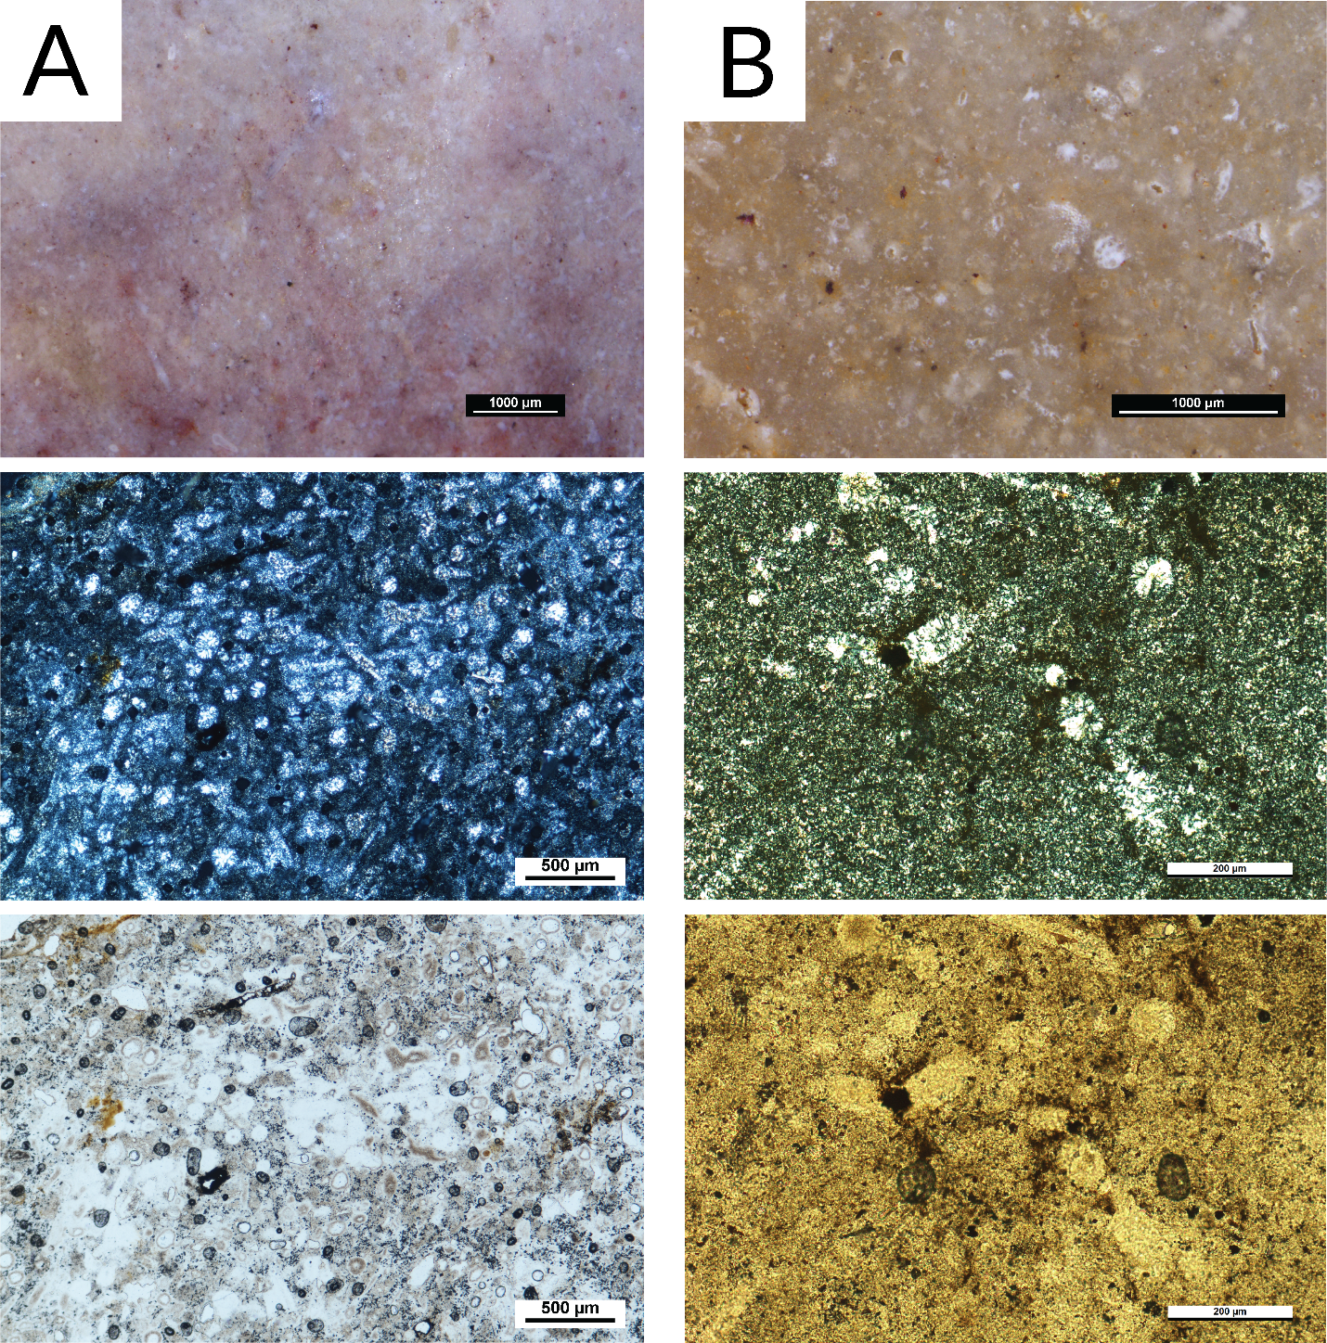

Fig. **: Column A – Sample SP36_PtA. Above: Macroscopic view with a stereomicroscope; Center and below: Microscopic view of a thin section (XPL and PPL respectively). Several unidentifiable fossils can be seen in the photo, along with the calcispheres. Column B – Sample SP39_AND. Above: Macroscopic view with a stereomicroscope; Center and below: Microscopic view of a thin section (XPL and PPL respectively). A small amount of calcispheres is present in the image, along with few unidentifiable fossils replaced by quartz/chalcedony.

On the eastern part of the Algarve, chert-bearing known formations are from the Middle to Upper Jurassic, known as the Malhão formation and the Jordana formation, respectively.

The Malhão formation chert (dating to the Middle Jurassic) was identified in three outcrops. Whenever in a primary outcrop, this chert was homogeneous. The secondary deposits were recent waterlines and slope deposits, and the cherts were often characterized by intense post-depositional alterations. In these cases, it was not possible to confirm the outcrop location. In these outcrops, the nodule frequency varied from common to abundant. The nodules are roundish, ranging between 3 to 5 cm in maximum width. In all cases, access to the outcrops was easy. Although the parent rock was hard, several chert nodules could be collected from the surface, accumulating further down in gentle slope deposits. The Malhão cherts show two differing macroscopic characteristics: pink/reddish cherts and grey cherts. In general, they are both characterized by a dull to medium luster, opaque to sub-translucent translucency, and smooth to semi-smooth feel. They are easily identifiable through the high amounts of macroscopically visible inclusions, which look like white speckling in plain sight. Under the stereomicroscope, several round fossils and long spicule-like shapes can be identified. The petrographic analysis shows for the Malhão cherts from Casal da Colina (primary and secondary outcrops) high amounts of dolomite within the chert. All of these cherts are characterized by a wackestone texture and a high variety of identifiable fossils (although all are poorly preserved and replaced by chalcedony or quartz). These fossils are Sponge spicules, Radiolarians, Ostracods, Echinoderms, Calcispheres, and possibly Tentaculites (Fig. **).

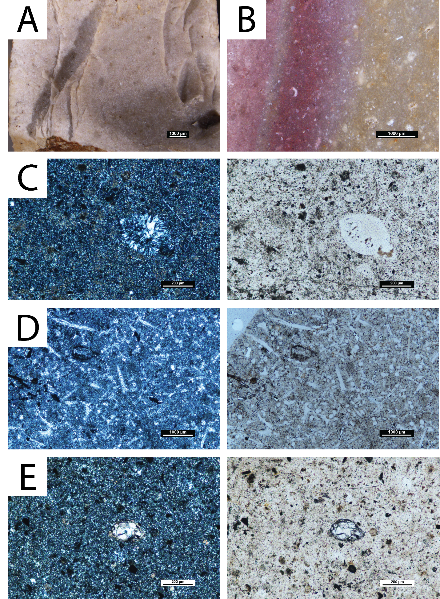

Fig. **: Macroscopic and microscopic views of chert samples from the Middle Jurassic Malhão outcrop. A – Sample SP50_CdC, macroscopic view with a stereomicroscope. B – Sample SP62_OLV, macroscopic view with a stereomicroscope. C – Microscopic view of SP50_CdC, XPL (left) and PPL (right). Detail of a fossil (possibly an Ostracod), replaced by two generations of chalcedony (1st generation in the outer edges and 2nd generation replacing the inside). D - Microscopic view of SP54_GUI, XPL (left) and PPL (right). General view of the thin section. Several fossil ghosts can be seen. Despite the poor preservation, it may be possible to identify a few fossils based on the size and morphology: 1) calcispheres or recrystallized radiolarians; 2) monaxon spicules pointed at one end.

The Jordana formation chert (Upper Jurassic) was identified in one area in the Algarve, above Moncarapacho in the Olhão parish. Whenever in a primary outcrop, the chert was homogeneous, although alternated with nodules of other lithologies within the parent rock. No chert was identified in any secondary deposits, which might be related to the anthropic alteration of the landscape. Smaller nodules broken from the parent rock were identified near the primary source in a field. Whenever embedded in the parent rock, the nodules varied in size (~1-10 cm) and were abundant, with a high level of difficulty in their removal, due to the hardness of the parent rock. The cherts show little macroscopic variability between nodule and outcrop. They are grey/brown (with visible yellow inclusions). Within nodules, however, the cherts are heterogeneous, with dull and shiny or smooth and semi-smooth feel areas. Some of the nodules also show the variability of translucency, with translucent areas, with a very fine grain, and little presence of visible inclusions. The petrographic analysis shows that the cherts range from a wackestone to packstone texture, which was already seen macroscopically. They are composed mostly of microcrystalline quartz, with the presence of fibrous chalcedony replacing the fossils and negligible percentages of other minerals. Fossils are poorly preserved in general, with a few being identifiable: Calcispheres, Bivalve shell, Sponge spicules, Ostracod, Echinoderms, and Gastropod (Fig. **).

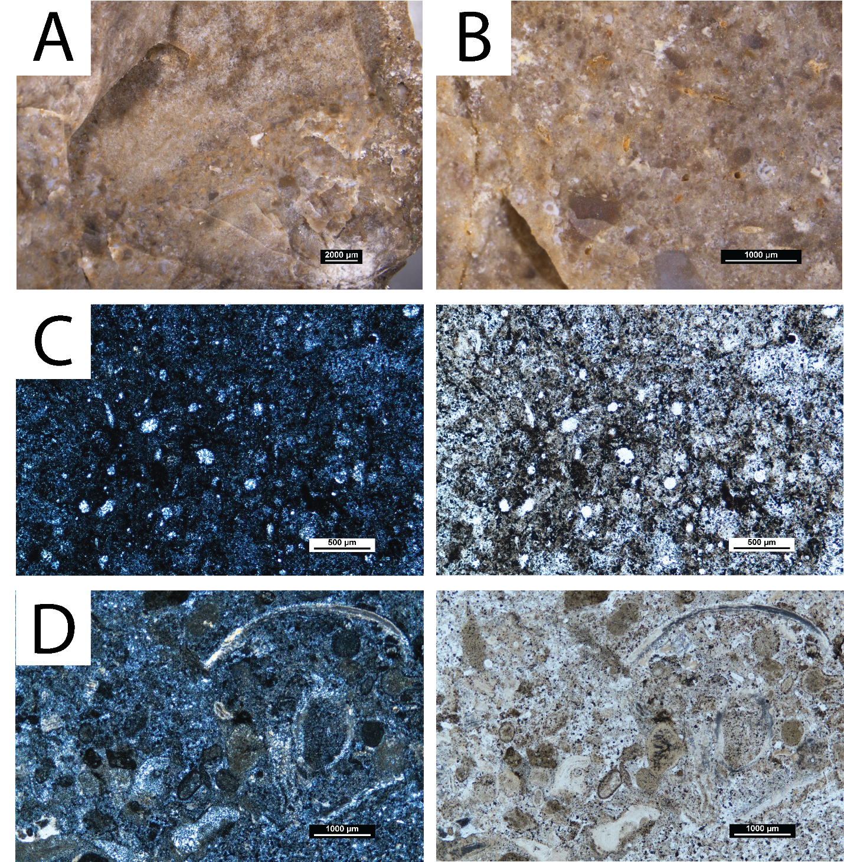

Fig. **: Macroscopic and microscopic views of chert samples from the Upper Jurassic Jordana outcrop. A – Sample SP58_JOR, macroscopic view with a stereomicroscope. B – Sample SP59_JOR, macroscopic view with a stereomicroscope. C – Microscopic view of SP56_JOR, XPL (left) and PPL (right). General view of the calcispheres in an area of the chert characterized by a large concentration of oxide patina and opaques. D - Microscopic view of SP58_JOR, XPL (left) and PPL (right). General view of the thin section. A large bivalve shell fragment is visible at the top.

It is important to note that the aforementioned chert geological samples represent the chert variability of the identified outcrops. However, a small number of outcrops described in regional geological maps were not identified or were not accessible. This includes four outcrops: 1) a Lower Jurassic outcrop with chert micronodules which was identified through a geological profile (Oliveira, 1992); 2) a Middle Jurassic outcrop located at the easternmost section of the Algarve with partially dolomitized clasts and chert nodules (Oliveira, 1992); 3) several unprospected locations from previous geoarchaeological works, all related to the Peral Anticline and reaching from central to eastern Algarve; 4) a possible chert exploitation archaeological site located on top of a chert source (Monte do Cerro), in eastern Algarve which was not identified and is possibly inaccessible (Bicho et al., 2003). All of these unidentifiable outcrops are located in the central or eastern portion of the Algarve. This may be related to the frequent landscape changes occurring due to agriculture or the population of previously uninhabited areas, which seldom occurs in the western Algarve by the cliff areas, where most outcrops are located.

# 5 Discussion

The prospection works and analyses of the collected geological samples show that the south of Portugal has a high potential for raw material studies, especially regarding chert. The presence of chert-bearing outcrops in the westernmost part of the Algarve, center, and east would provide several possibilities for sourcing and procurement whenever groups moved throughout the territory. This is further important when we consider the geology of this region. The geology of the Algarve itself may have played an important part in how groups procured their raw materials, specifically, their chert, a task that has been identified as essential for hunter-gatherer groups. To the south, communities would only have access to chert-bearing outcrops up to the coast. To the north, the mountain range would not only have provided no chert nodules but may have also hampered the movement of populations, forcing groups to move east and west instead of north or south. This movement may have facilitated the gathering of cherts from different formations within the Algarve, posteriorly then brought into the sites. Especially for Middle and Upper Paleolithic occupations, understanding the sources of chert in the Algarve may provide data about where in the territory these groups were sourcing their raw materials, and how they were using the territory when their movement was constrained by the Peninsula’s natural barriers. Although this question remains unanswered, this study stands as a further step to tackle these questions in the Algarve region, as it may provide the necessary basis for comparative studies with archaeological assemblages.

However, tracking these movements and procurement patterns is only possible if the cherts from the different formations and outcrops can be traced back to their sources. This presented itself as the first caveat for this type of study, since for the Algarve, for example, all cherts come from Jurassic formations in pelagic environments. Despite the similar formation environments, in general, there seem to be relevant differences between the cherts of different formations and periods. This is further relevant given the fact that they are geographically distant. Within formations, however, there are no discernable differences, both at a macroscopic and petrographic level, as these do not seem to be useful to distinguish between outcrops. That is most obvious on the Lower Jurassic outcrops of the western Algarve. The identified chert groups, which varied mostly in color and fossil content, are present in several outcrops. In this region, the variables which may be better used to understand which outcrops were visited may be the quality and size of the nodules. The latter, for example, is an important variable in the Belixe outcrops, which show the largest volumes of rock, even if the knapping quality is worse than some other available, smaller nodules. Size may be used in conjunction with other technological data, to understand whether different nodules were being explored differently based on their size, or their procurement was being preferred in relation to other smaller nodules in possibly closer outcrops in the region.

The Upper Jurassic nodules of the western Algarve also show larger volumes than those from the Lower Jurassic. Translucency also seems to be a good macroscopic indicator to distinguish between western Algarve Lower and Upper Jurassic cherts, since the latter are characterized as sub-translucent. However, for a reliable distinction between the Lower Jurassic and the Upper Jurassic cherts, petrographic analyses and the identification of calcispheres may be necessary.

The differences identified among the cherts of the various formations can be seen both at a macroscopic and petrographic level. Given the formation setting, petrographically, all the cherts from the Algarve are fairly homogeneous - marine origin, in limestone or dolomitic limestone rocks, all formed during the Jurassic. The use of fossils for the identification of the cherts is also difficult since these are often not well preserved enough to allow the identification of species that may connect a group of cherts. The size, frequency, and preservation state of the fossils seem to be, then, one of the defining criteria for discerning cherts from different formations, and thus, different geographic areas. These characteristics seem to be observable macroscopically, as well, allowing the cherts from the three different areas and formations - West, Jordana, and Malhão - to be differentiated without the need for thin sections. This is especially important for archaeological collections, especially those which may be small, with small archaeological pieces, or for the study of older collections to which other means of analysis may not be available.

This data seems to confirm the potential of a macroscopic analysis to study the cherts of the Algarve. Albeit applying different methodologies, such as petrographic analyses, to these cherts is a way of completing the petrographic study of a collection, reliably applying mostly a macroscopic analysis to the assemblages coming from southern Portugal helps tackle issues such as the destructiveness, costliness, and time consumption of some methods.

The research was able to complete the collection, providing samples of the available cherts which may be compared with archaeological samples. However, there are some caveats to this type of study. Landscapes have changed through time, both naturally and with the influence of modern society. House constructions, agricultural fields, and roads, for example, have modified the landscape, possibly altering the availability and visibility of raw materials. Other natural processes, such as the development of biomantle or soil cover may also hamper raw material visibility in the landscape. Similarly, environmental changes may have had an impact on raw material availability, through its impact on surface processes which expode, erode and transport the raw materials (Pereira and Benedetti, 2013). As such, it is important to keep in mind that current raw material sources, and specifically chert ones which may be visibly sutble in the landscape, may not correspond to the sources which were available in the past.

Another caveat regarding chert sources, especially in a geographic area like the Algarve, is the possibility of some outcrops being submerged. Previous studies have identified the existence of Jurassic lithologies on the west coast, submerged by water (Terrinha et al., 2006). These were mainly surveys done by oil companies which were able to obtain the submerged stratigraphies on the southwestern coast of Portugal and that revealed Jurassic limestones and dolomites, although the presence of chert is not described and remains unknown. Whether these submerged lithologies are different from the currently emerged ones is also uncertain. These studies also revealed that Jurassic lithologies were covered by more recent geological layers, including Pliocene and Pleistocene layers, thus forming before and/or during Paleolithic occupations of the territory (Terrinha et al., 2006).

In times when the sea level was similar to the current one, the submerged lithologies would not have been accessible, even during low tide. This includes periods before and after the LGM. However, during periods when the sea level was lower due to water freezing in the polar caps, as during the LGM for example, large portions of the coast that had been submersed would have been accessible. During this period, in Portugal, the coast would probably be close to the continental platform, ~120 m below the sea level (Dias et al., 1997, 2000). Especifically in the western Algarve, the coastline may have been displaced ~10-15 km offshore from the present coastline, also due to coastal uplift processes (Bicho and Haws, 2008). Although currently unknown, it may be possible that during periods like the LGM, limestone and dolomite Jurassic lithologies, with chert nodules, might have been exposed and available. When studying chronologies characterized by cold and harsh climatic conditions with impacts on sea level changes and mixed with coastal uplift events, it is relevant to keep in mind that the chert variability present in the current coastline may not necessarily reflect the variability in the past.

Despite the caveat, this raises the possibility to understand whether this new portion of landmass altered the raw material procurement patterns of these groups, or added new resources which had been previously unavailable. Studies that compare Gravettian and Magdalenian assemblages (with higher mean sea-levels, and possibly even similar to current coastlines) to Proto-Solutrean and Solutrean assemblages (with LGM low mean sea-levels), within one single site, may give new insights into this question.

# 5 Conclusion

In this paper we identified several sources of chert nodules in southern Portugal and characterized the regional cherts, which were of critical importance for hunter-gatherer communities during the Late Pleistocene. For this we applied a multilayered raw material analysis approach, composed of macroscopic and petrographic analyses. The results show the presence of four different chert formations, dispersed in the western and eastern Algarve. Within formations, there is variability in the nodules and the outcrops. There are however identifiable macroscopic and petrographic differences between formations which allow their distinction. Although the petrographic analysis is essential to identify the fossils present in the chert, a macroscopic approach seems to be pertinent for a quick and inexpensive analysis to distinguish between cherts of the different formations.

The presence of chert sources in the Algarve region, with distinguisheable characteristics between formations, which may be analysed preliminarily through macroscopic approaches, shows the potential for chert raw material studies of Late Pleistocene (and possibly Holocene) in archaeological sites in this key area. Further steps in our study will include the use of the data gathered in the present study and the completed LusoLit lithotheque to study chert use from sites with UP chronologies such as Vale Boi, and participate in the discussion of Human adaptations throughout the Late Pleistocene.

# 6 Acknowledgements

### 7.0.1 Colophon

This report was generated on 2022-08-31 10:14:24 using the following computational environment and dependencies:

#> - Session info ---------------------------------------------------------------  
#> setting value  
#> version R version 4.0.4 (2021-02-15)  
#> os Windows 10 x64 (build 19044)  
#> system x86_64, mingw32  
#> ui RTerm  
#> language (EN)  
#> collate English_United States.1252  
#> ctype English_United States.1252  
#> tz Europe/London  
#> date 2022-08-31  
#> pandoc 2.18 @ C:/Program Files/RStudio/bin/quarto/bin/tools/ (via rmarkdown)  
#>   
#> - Packages -------------------------------------------------------------------  
#> package * version date (UTC) lib source  
#> assertthat 0.2.1 2019-03-21 [1] CRAN (R 4.0.5)  
#> base64enc 0.1-3 2015-07-28 [1] CRAN (R 4.0.3)  
#> bit 4.0.4 2020-08-04 [1] CRAN (R 4.0.5)  
#> bit64 4.0.5 2020-08-30 [1] CRAN (R 4.0.5)  
#> bookdown 0.25 2022-03-16 [1] CRAN (R 4.0.5)  
#> brio 1.1.3 2021-11-30 [1] CRAN (R 4.0.5)  
#> cachem 1.0.6 2021-08-19 [1] CRAN (R 4.0.5)  
#> callr 3.7.0 2021-04-20 [1] CRAN (R 4.0.5)  
#> class 7.3-20 2022-01-13 [1] CRAN (R 4.0.5)  
#> classInt 0.4-3 2020-04-07 [1] CRAN (R 4.0.5)  
#> cli 3.3.0 2022-04-25 [1] CRAN (R 4.0.4)  
#> colorspace 2.0-3 2022-02-21 [1] CRAN (R 4.0.5)  
#> crayon 1.5.0 2022-02-14 [1] CRAN (R 4.0.5)  
#> data.table * 1.14.2 2021-09-27 [1] CRAN (R 4.0.5)  
#> DBI 1.1.2 2021-12-20 [1] CRAN (R 4.0.5)  
#> desc 1.4.1 2022-03-06 [1] CRAN (R 4.0.5)  
#> devtools 2.4.3 2021-11-30 [1] CRAN (R 4.0.5)  
#> digest 0.6.28 2021-09-23 [1] CRAN (R 4.0.5)  
#> dplyr * 1.0.8 2022-02-08 [1] CRAN (R 4.0.5)  
#> e1071 1.7-9 2021-09-16 [1] CRAN (R 4.0.5)  
#> ellipsis 0.3.2 2021-04-29 [1] CRAN (R 4.0.5)  
#> evaluate 0.15 2022-02-18 [1] CRAN (R 4.0.5)  
#> fansi 0.5.0 2021-05-25 [1] CRAN (R 4.0.5)  
#> farver 2.1.0 2021-02-28 [1] CRAN (R 4.0.5)  
#> fastmap 1.1.0 2021-01-25 [1] CRAN (R 4.0.5)  
#> flextable * 0.7.0 2022-03-06 [1] CRAN (R 4.0.5)  
#> fs 1.5.2 2021-12-08 [1] CRAN (R 4.0.5)  
#> gdtools 0.2.4 2022-02-14 [1] CRAN (R 4.0.5)  
#> generics 0.1.2 2022-01-31 [1] CRAN (R 4.0.5)  
#> ggplot2 * 3.3.5 2021-06-25 [1] CRAN (R 4.0.5)  
#> ggrepel * 0.9.1 2021-01-15 [1] CRAN (R 4.0.5)  
#> ggspatial * 1.1.5 2021-01-04 [1] CRAN (R 4.0.5)  
#> glue 1.6.2 2022-02-24 [1] CRAN (R 4.0.5)  
#> gtable 0.3.0 2019-03-25 [1] CRAN (R 4.0.5)  
#> here 1.0.1 2020-12-13 [1] CRAN (R 4.0.5)  
#> highr 0.9 2021-04-16 [1] CRAN (R 4.0.5)  
#> hms 1.1.1 2021-09-26 [1] CRAN (R 4.0.5)  
#> htmltools 0.5.2 2021-08-25 [1] CRAN (R 4.0.5)  
#> httr 1.4.2 2020-07-20 [1] CRAN (R 4.0.5)  
#> kableExtra * 1.3.4 2021-02-20 [1] CRAN (R 4.0.5)  
#> KernSmooth 2.23-20 2021-05-03 [1] CRAN (R 4.0.5)  
#> knitr 1.36 2021-09-29 [1] CRAN (R 4.0.5)  
#> lattice 0.20-45 2021-09-22 [1] CRAN (R 4.0.5)  
#> lifecycle 1.0.1 2021-09-24 [1] CRAN (R 4.0.5)  
#> magrittr 2.0.1 2020-11-17 [1] CRAN (R 4.0.5)  
#> memoise 2.0.1 2021-11-26 [1] CRAN (R 4.0.5)  
#> munsell 0.5.0.9000 2021-11-11 [1] Github (cwickham/munsell@e539541)  
#> officer 0.4.2 2022-03-23 [1] CRAN (R 4.0.5)  
#> pillar 1.7.0 2022-02-01 [1] CRAN (R 4.0.5)  
#> pkgbuild 1.3.1 2021-12-20 [1] CRAN (R 4.0.5)  
#> pkgconfig 2.0.3 2019-09-22 [1] CRAN (R 4.0.5)  
#> pkgload 1.2.4 2021-11-30 [1] CRAN (R 4.0.5)  
#> prettyunits 1.1.1 2020-01-24 [1] CRAN (R 4.0.5)  
#> processx 3.5.2 2021-04-30 [1] CRAN (R 4.0.5)  
#> proxy 0.4-26 2021-06-07 [1] CRAN (R 4.0.5)  
#> ps 1.6.0 2021-02-28 [1] CRAN (R 4.0.5)  
#> purrr 0.3.4 2020-04-17 [1] CRAN (R 4.0.5)  
#> R6 2.5.1 2021-08-19 [1] CRAN (R 4.0.5)  
#> Rcpp 1.0.8.3 2022-03-17 [1] CRAN (R 4.0.5)  
#> readr * 2.1.2 2022-01-30 [1] CRAN (R 4.0.5)  
#> remotes 2.4.2 2021-11-30 [1] CRAN (R 4.0.5)  
#> rlang 1.0.2 2022-03-04 [1] CRAN (R 4.0.5)  
#> rmarkdown 2.13 2022-03-10 [1] CRAN (R 4.0.5)  
#> rnaturalearth * 0.1.0 2017-03-21 [1] CRAN (R 4.0.5)  
#> rnaturalearthdata * 0.1.0 2017-02-21 [1] CRAN (R 4.0.5)  
#> rprojroot 2.0.2 2020-11-15 [1] CRAN (R 4.0.5)  
#> rstudioapi 0.13 2020-11-12 [1] CRAN (R 4.0.5)  
#> rvest 1.0.2 2021-10-16 [1] CRAN (R 4.0.5)  
#> scales 1.1.1 2020-05-11 [1] CRAN (R 4.0.5)  
#> sessioninfo 1.2.2 2021-12-06 [1] CRAN (R 4.0.5)  
#> sf * 1.0-7 2022-03-07 [1] CRAN (R 4.0.5)  
#> sp 1.4-6 2021-11-14 [1] CRAN (R 4.0.5)  
#> stringi 1.7.6 2021-11-29 [1] CRAN (R 4.0.5)  
#> stringr 1.4.0 2019-02-10 [1] CRAN (R 4.0.5)  
#> svglite 2.1.0 2022-02-03 [1] CRAN (R 4.0.5)  
#> systemfonts 1.0.4 2022-02-11 [1] CRAN (R 4.0.5)  
#> testthat 3.1.2 2022-01-20 [1] CRAN (R 4.0.5)  
#> tibble 3.1.6 2021-11-07 [1] CRAN (R 4.0.5)  
#> tidyr * 1.2.0 2022-02-01 [1] CRAN (R 4.0.5)  
#> tidyselect 1.1.2 2022-02-21 [1] CRAN (R 4.0.5)  
#> tzdb 0.2.0 2021-10-27 [1] CRAN (R 4.0.5)  
#> units 0.8-0 2022-02-05 [1] CRAN (R 4.0.5)  
#> usethis 2.1.5 2021-12-09 [1] CRAN (R 4.0.5)  
#> utf8 1.2.2 2021-07-24 [1] CRAN (R 4.0.5)  
#> uuid 1.0-4 2022-03-16 [1] CRAN (R 4.0.5)  
#> vctrs 0.3.8 2021-04-29 [1] CRAN (R 4.0.5)  
#> viridisLite 0.4.0 2021-04-13 [1] CRAN (R 4.0.5)  
#> vroom 1.5.7 2021-11-30 [1] CRAN (R 4.0.5)  
#> webshot 0.5.2 2019-11-22 [1] CRAN (R 4.0.5)  
#> withr 2.5.0 2022-03-03 [1] CRAN (R 4.0.5)  
#> xfun 0.30 2022-03-02 [1] CRAN (R 4.0.5)  
#> xml2 1.3.3 2021-11-30 [1] CRAN (R 4.0.5)  
#> yaml 2.2.1 2020-02-01 [1] CRAN (R 4.0.5)  
#> zip 2.2.0 2021-05-31 [1] CRAN (R 4.0.5)  
#>   
#> [1] C:/Users/Meran/Documents/R/win-library/4.0  
#> [2] C:/Program Files/R/R-4.0.4/library  
#>   
#> ------------------------------------------------------------------------------

The current Git commit details are:

#> Local: master C:/Users/Meran/Documents/workflows/article1  
#> Remote: master @ origin (https://github.com/jbelmiro/article1.git)  
#> Head: [ec61d28] 2022-05-18: - first knit test - Introduction progress